**第一步：通过深圳市科技业务管理系统登录**Log in to the website of Shenzhen Science and Technology Innovation Commission (SZSTI) [**https://sticapply.sz.gov.cn/**](https://sticapply.sz.gov.cn/)

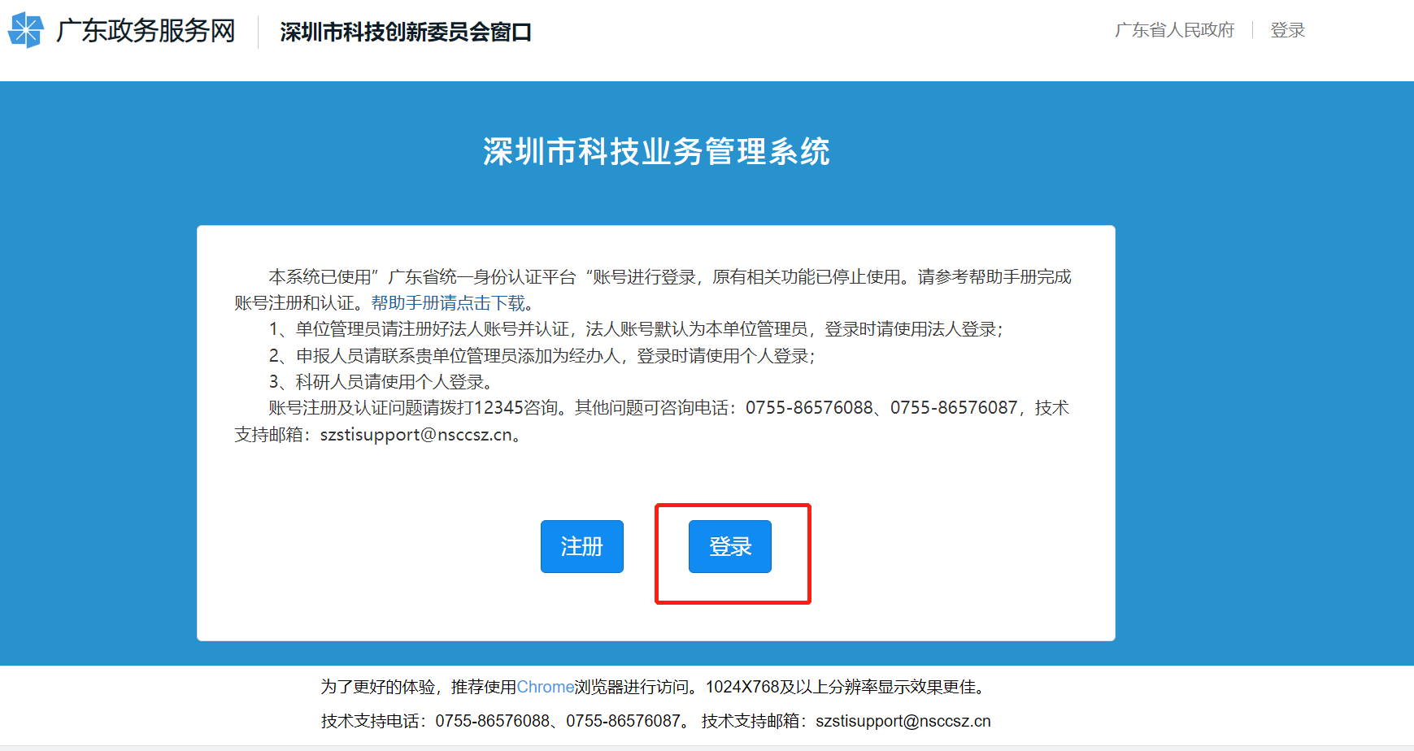

**第二步：a. 微信扫码登录，仅支持个人用户登录（大陆身份证持有者，无需注册即可使用。）** Use your WeChat, scan the code to login. Log in the “Yue Sheng Shi” via facial recognition. Only support individual user login (mainland ID card users) , you can use it without registration.

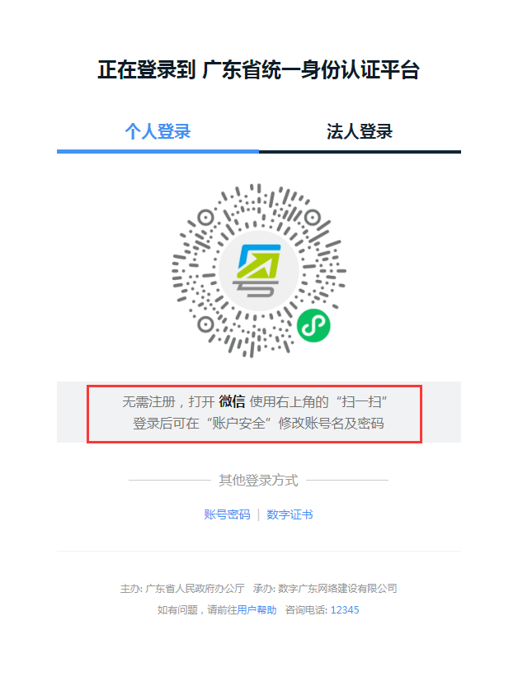

**b. 账号密码登录：如若您没有注册过广东省统一身份认证平台，请先注册。如若您注册过但忘记登录账号和密码，您可重新找回登录账号及密码。** If you have not registered account in the unified identity authentication platform of Guangdong Province, please register first. If you have already registered, but forget your login account and password, you can retrieve the login account and password.

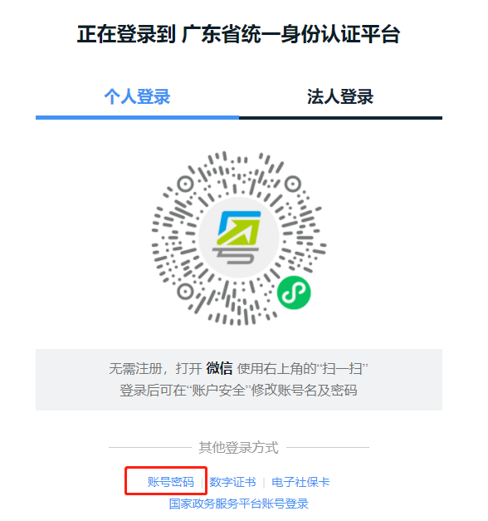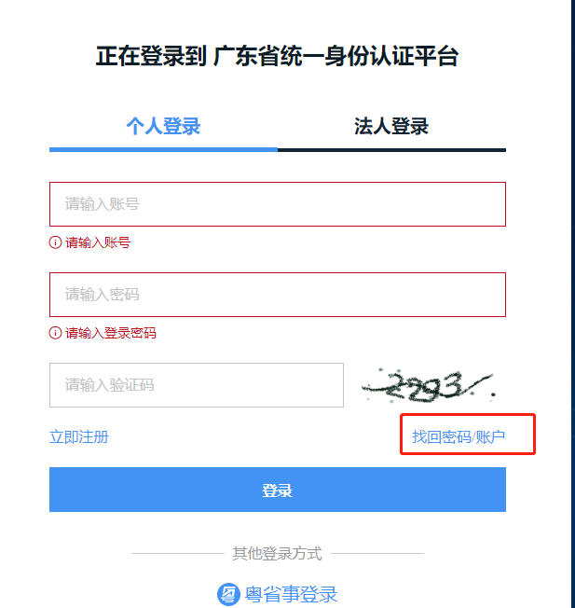

注：因深圳市在线项目申报的账户可信等级需达到四级及以上，非大陆身份证用户，需本人现场办理实名核验业务后方可登录系统。

有部分老师因办理过个税补贴等业务，或持有港澳台居住证，即已办理过实名认证，即可登陆系统，不用重复现场实名认证。（**可通过**[**http://tyrz.gd.gov.cn/**](http://tyrz.gd.gov.cn/)**登陆后，查看您的信用等级**）

建议各位老师，先按正常流程尝试登陆系统。如无法通过，请您现场办理实名认证或因疫情原因，如您不方便现场办理，[请联系科研处徐雅青xuyaqing@cuhk.edu.cn](mailto:%E8%AF%B7%E8%81%94%E7%B3%BB%E7%A7%91%E7%A0%94%E5%A4%84%E5%BE%90%E9%9B%85%E9%9D%92xuyaqing@cuhk.edu.cn)，获取临时系统登录链接。

Because the account credibility level declared by Shenzhen online project needs to reach level 4 or above, non-mainland ID card users can log into the system only after they handle the real name verification business on site.

Some teachers can log in to the system without repeating the on-site real name authentication, because they have handled individual income tax subsidies or other businesses, or hold a residence permit in Hong Kong, Macao and Taiwan etc. (available through http://tyrz.gd.gov.cn/ to check your credit rating after logging in)

Please try to log into the system before you apply for real name certification on site. If it's inconvenient for you to apply on site due to the epidemic, please contact Xu Yaqing , xuyaqing@cuhk.edu.cn , get the temporary system login link.

*地址：深圳市龙岗区龙翔大道8033-1号龙岗区行政服务大厅（龙岗区政府旁）二楼综合窗口。Address: Comprehensive window on Floor 2, Administrative Service Hall of Longgang District (next to Longgang District Government), No. 8033-1 Longxiang Avenue, Longgang District, Shenzhen City.*

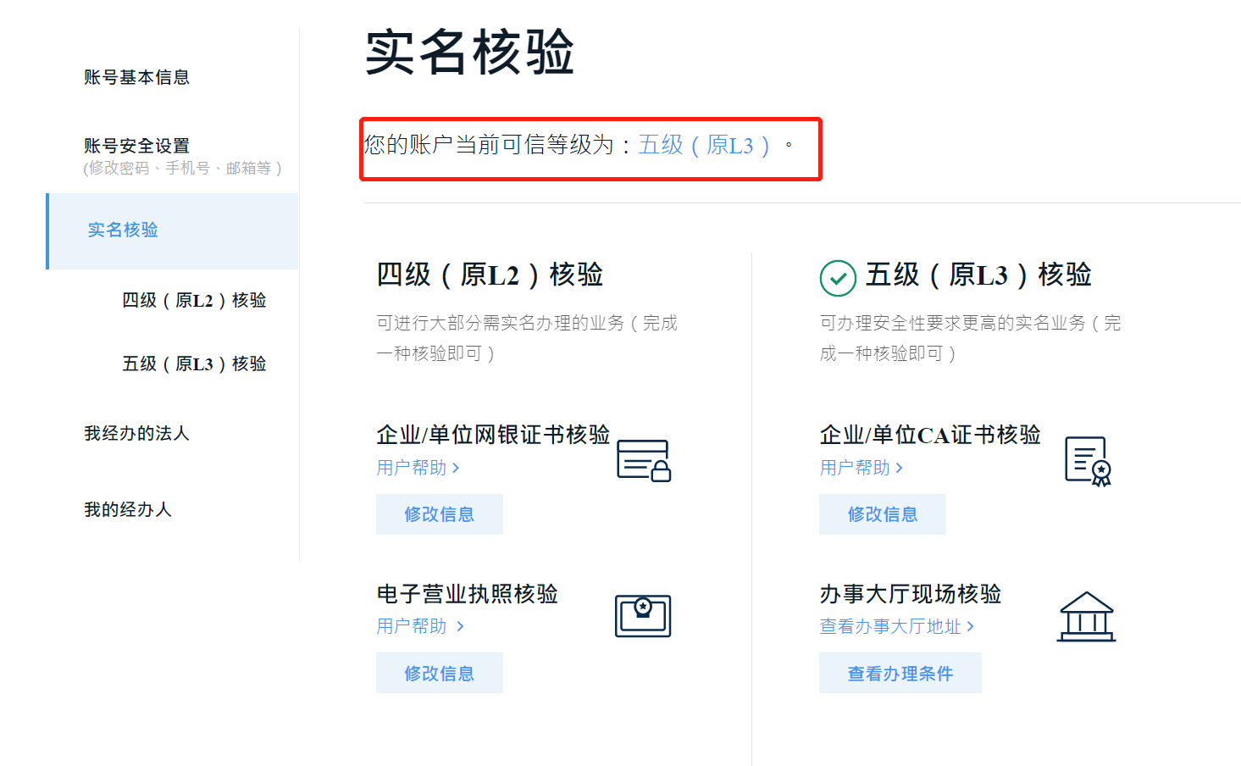

**第三步：登陆后，请选择“香港中文大学（深圳）”After login successfully, please select “香港中文大学（深圳）”**

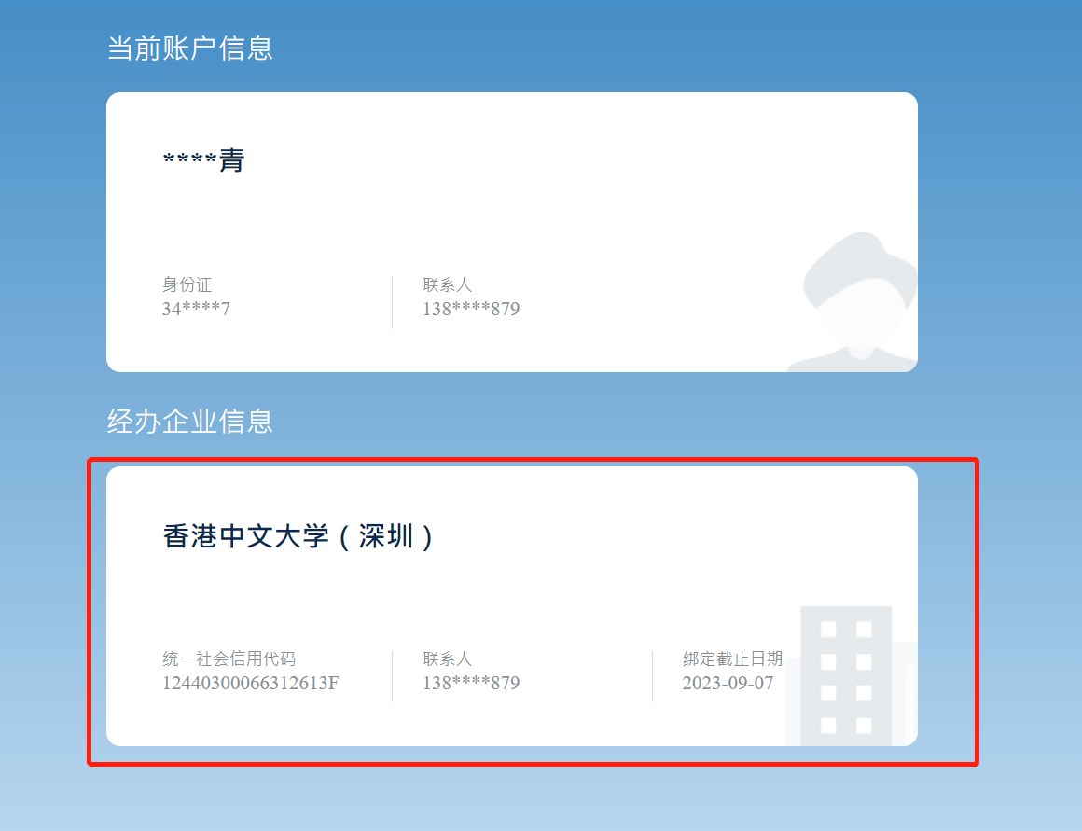

第四步：请选择“市科技创新委”，“科技计划”“项目征集”，点击“未提交”后选择左上角“项目申报”。Please select “市科技创新委”，“科技计划”“项目征集”， “未提交”, “项目申报”。

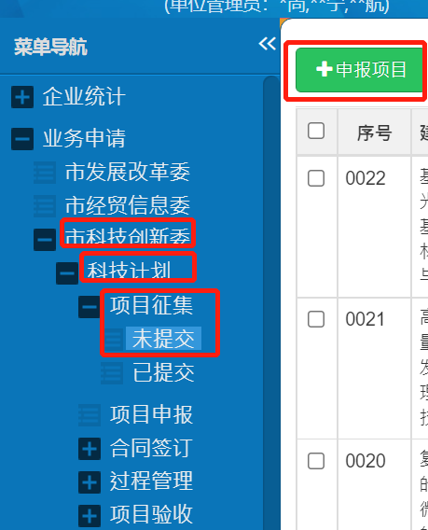

**第五步：选择第五项“基础研究（重点项目）征集（2022-04-11 18：00申报截止）”即可看到项目征集表。Please choose the fifth item “基础研究（重点项目）征集（2022-04-11 18：00申报截止）”**

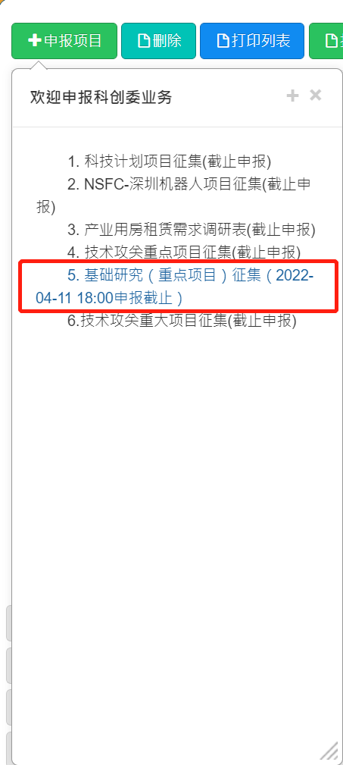

**第六步：填写完成您的征集表后，点击“提交”后，审批状态为“待管理员审核”即可。学校科研处形式审核后，如有问题会及时向您反馈，如没有问题，学校会统一提交。After completing your collection form, click "提交" and the approval status will be "待管理员审核". After the formal review, RAO will give feed back in time if there are any problems. If there are no problems, we will submit them uniformly.**

