1. 登录科创委网站http://stic.sz.gov.cn/，选择“业务系统（申报单位）”。

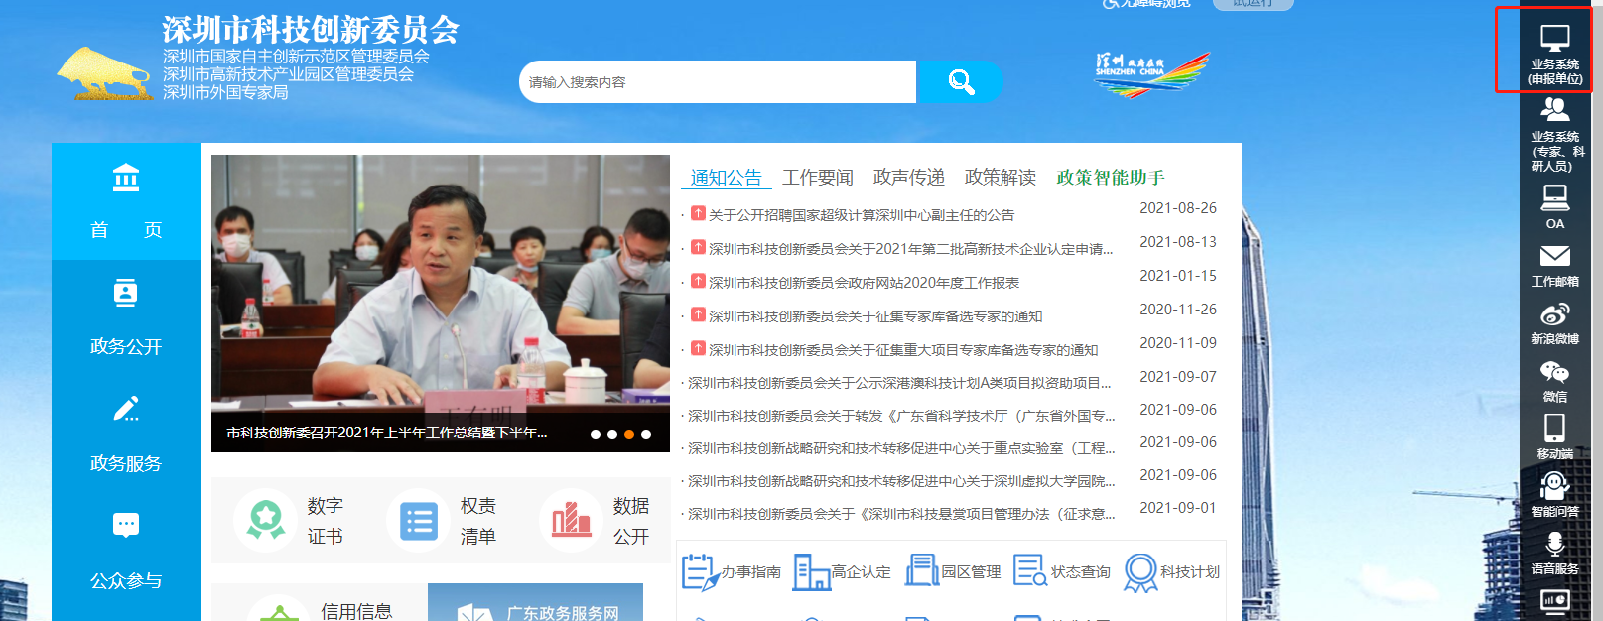

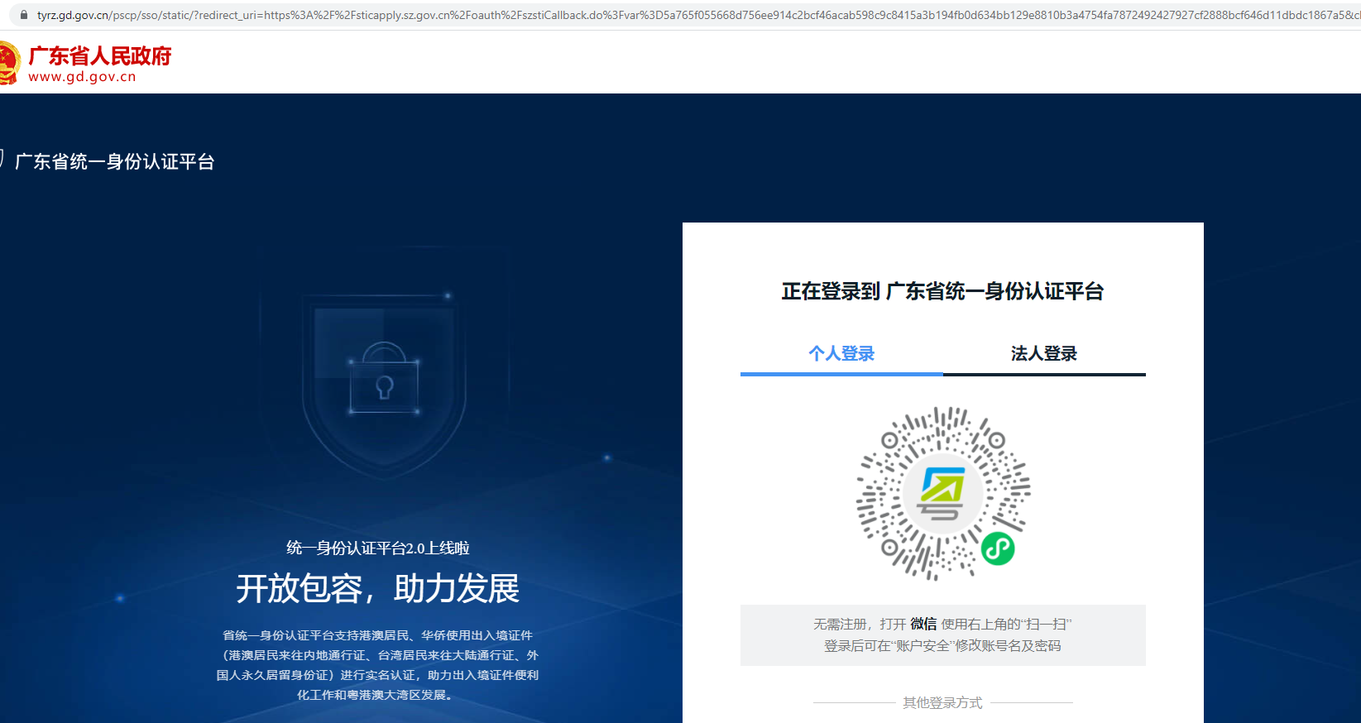

***2.（a）如若您已经有广东省统一身份认证平台的账号***

请您发送邮件至科研处徐雅青处xuyaqing@cuhk.edu.cn告知您的广东省统一身份认证平台的**个人登录账号以及姓名**，由科研处统一将您的账号添加为经办人。

***(b)如若您之前未注册过该平台，请您通过以下方式注册。***

* + **账号密码注册**

支持**个人**用户的账号注册，分3步：输入注册信息、实名核验、注册完成。

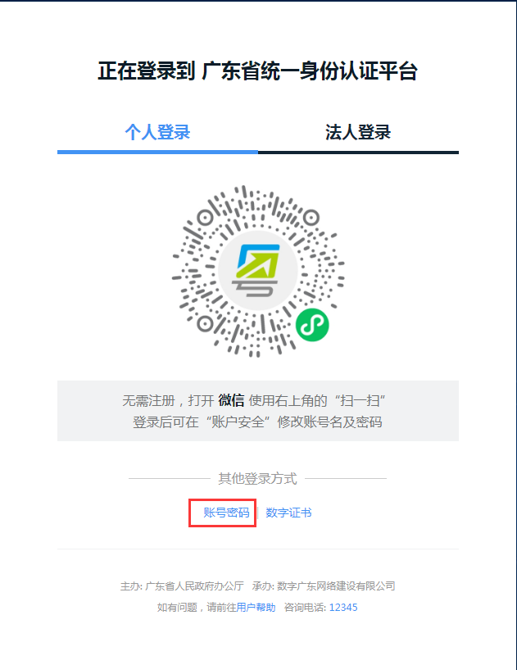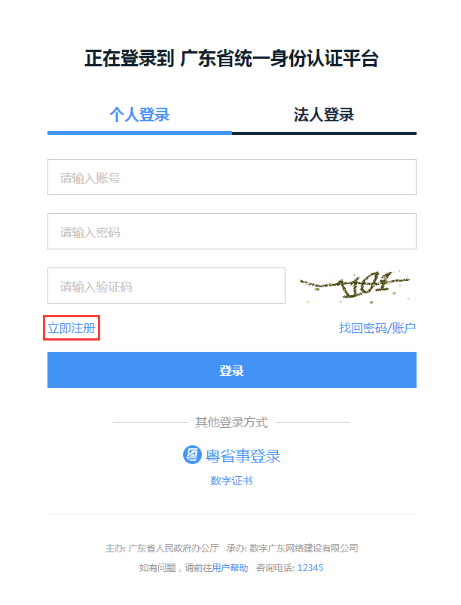

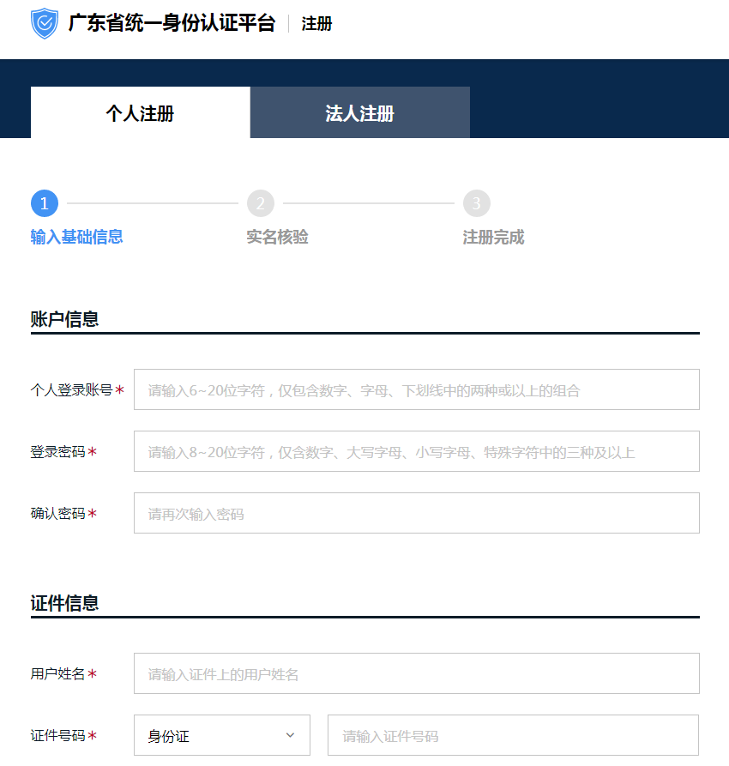

* + **粤省事刷脸登录**

仅支持**个人**用户登录，**无需注册**即可使用。

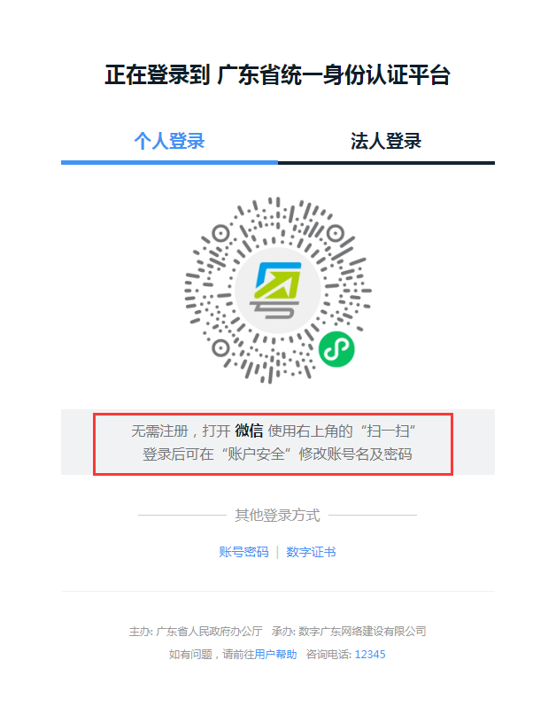

***(c)如若您注册过广东省统一身份认证平台，但忘记登录账号和密码，您可重新找回登录账号及密码。***

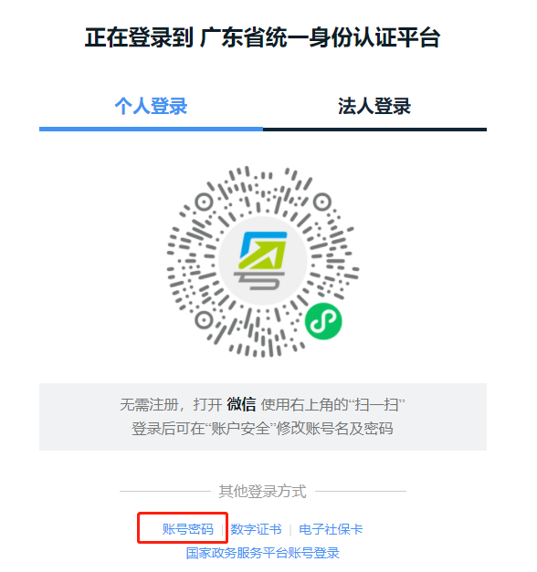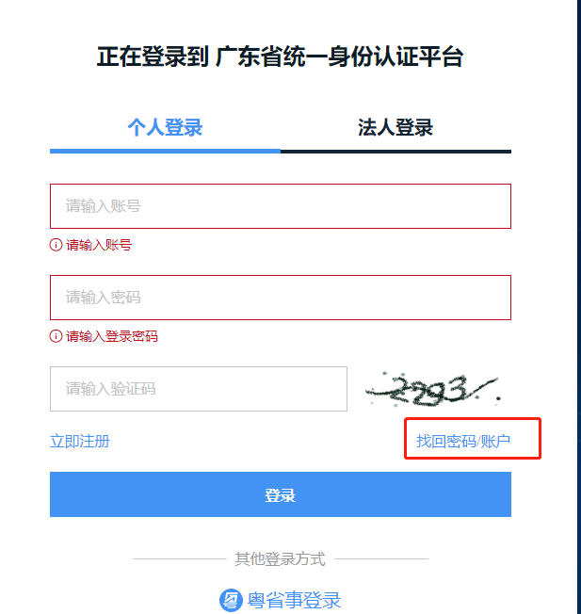

**如您在使用广东省统一身份认证平台的过程中遇到问题，可前往**[**帮助中心**](http://www.gdzwfw.gov.cn/portal/help/index.html)**或拨打咨询电话12345**。

1. 待科研处和您确认已添加经办人后，请您再次登录广东统一身份认证平台<https://www.gdzwfw.gov.cn/>， 选择“我经办的法人”，绑定。

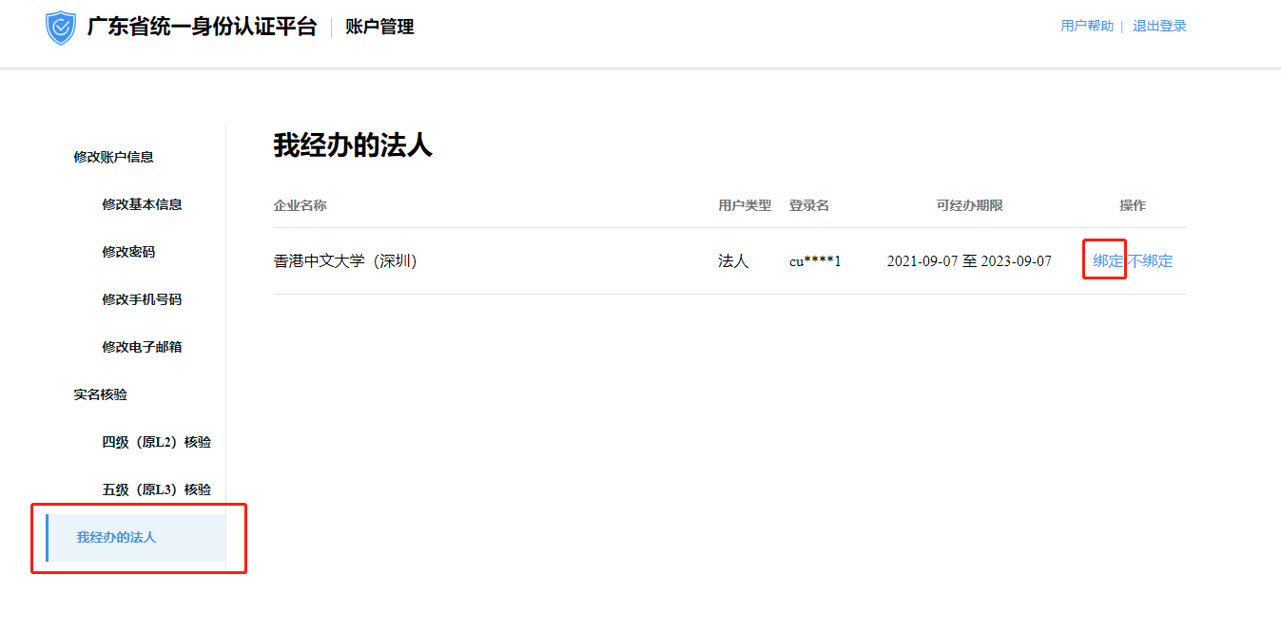

1. 请您再次登录科创委网站http://stic.sz.gov.cn/，选择“业务系统（申报单位）”后登录。

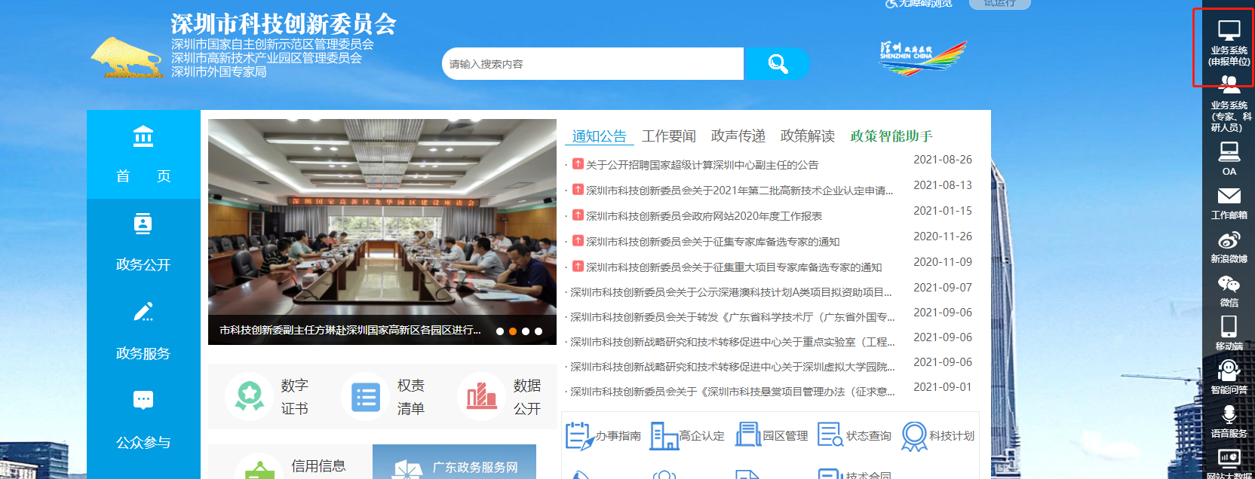

1. 当您登录后进入此页面，选择“香港中文大学（深圳）”后，您将可以看到您之前的市项目申报信息。

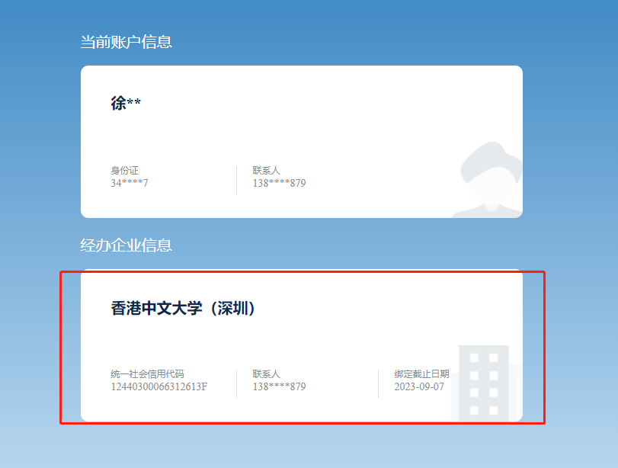

1. Log in to the website of Shenzhen Science and Technology Innovation Commission (SZSTI) <http://stic.sz.gov.cn/> and select " Information Systems (Application Unit)" (see the red box in the picture below).



2. (a) If you already have an account of the unified identity authentication platform of Guangdong Province, please send an email to Xu Yaqing (RAO), xuyaqing@cuhk.edu.cn to include **your login account and your name** and we will add your information in the system.

(b) If you have not registered in the platform yet, please register through the following methods.

* Account registration

Individual user account registration with the following 3 steps: input registration information, real name verification, registration completion.





* Log in the “Yue Sheng Shi” via facial recognition. Only support individual user login, you can use it without registration.



(c) If you have registered account in the unified identity authentication platform of Guangdong Province, but forget your login account and password, you can retrieve the login account and password. If you encounter any problems, you can browse the following website for help (http://www.gdzwfw.gov.cn/portal/help/index.html) or call 12345.



3. After we confirm with you that your information has been added in the system, please log in the platform again <https://www.gdzwfw.gov.cn/> and select the last row "my legal entity", and click “binding my account”.



4. Please log in <http://stic.sz.gov.cn/> again, and select " Information Systems (Application Unit)" (the same as step 1).



1. After you log in and select "The Chinese University of Hong Kong (Shenzhen)", all you research project you submitted to SZSTI will show up on the website.

